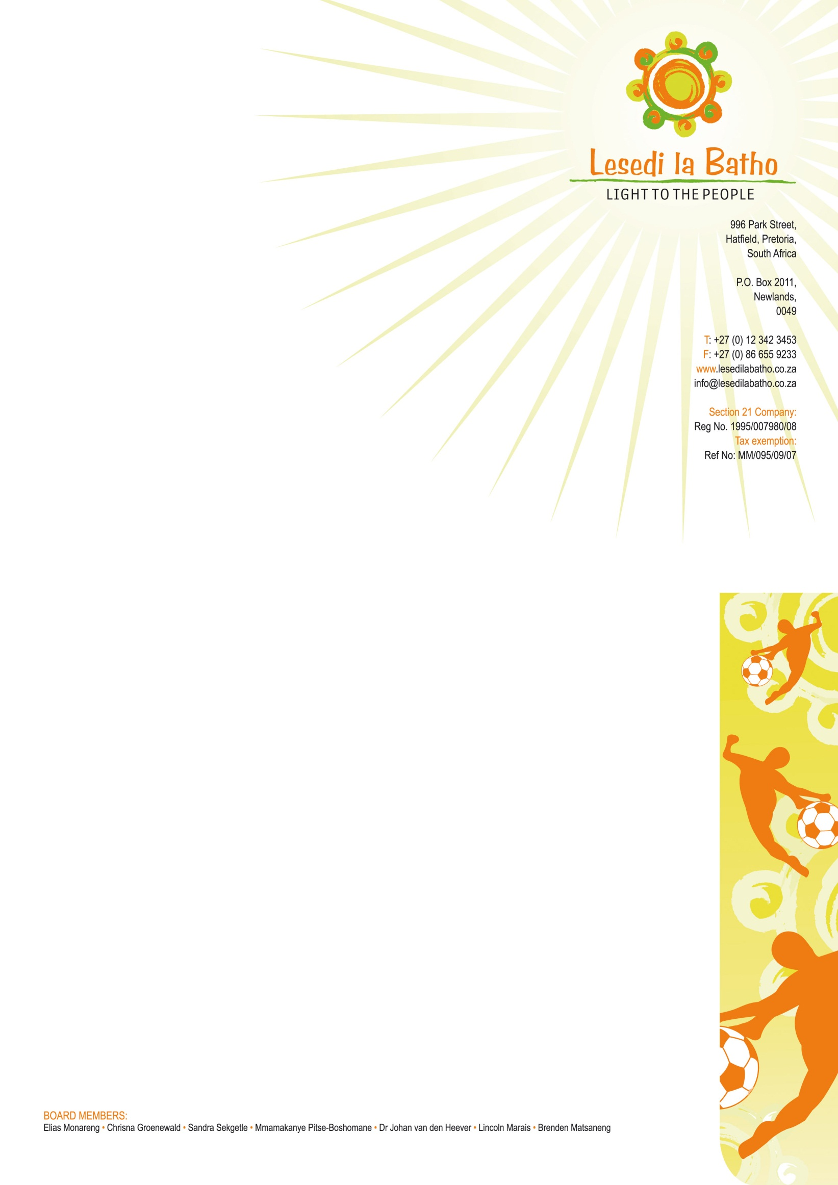

WHO ARE WE?

Lesedi la Batho is a faith-based NGO that seeks to inspire, empower, motivate, engage and equip the youth and the community at large. We aim to do so through different projects that address youth development through sport, education, skills training, social enterprise development, community wellness, arts and culture. The mission of the organisation is to provide the community and particularly the youth with the opportunities and skills required to realize their full potential and purpose and so become meaningfully contributing members of society.

OUR OBJECTIVES

- To promote social change and justice in communities, including through sport and education;
- To promote social cohesion and economic empowerment of communities;
- To empower the youth to take the lead in improving their own lives, finding solutions to their problems and satisfying their needs by positively focusing on, and utilizing, both individual and communal assets;
- To provide the youth and community members with opportunities that will enable them to develop creative ways to enhance the quality of their lives and that of others;
- To be a catalyst for social entrepreneurship by creating the environment for the development of innovative, effective and measurable solutions for communities; and
- To provide social services to vulnerable mothers in order to empower them, and provide them with life options, while their babies are nurtured and loved in a safe environment.

OUR BACKGROUND
In 2004 Lesedi La Batho began as a project under a NGO called SA Cares for Life. A contract was signed with the North Development Corporation to rent a building in the Mabopane community from where caring services were delivered to women, children and families.
In 2007, an informal soccer team, the Lesedi Strikers wasformed to provide a positive recreational activity for the youth living in close proximity to the Lesedi la Batho Centre.
In 2009 the team was fortunate to participate in the biggest youth soccer tournament in the world held annually in Oslo, Norway. It was indeed a life changing experience for the children who were fortunate to go to Norway even though they did not fare well against the “giants” they played against. We realised that these young boys would never be able to grow to their full potential emotionally and physically without further investment in their lives. Lesedi la Batho was birthed as a result of the need to create more opportunities for the Lesedi Strikers and subsequently lead to the development of a holistic youth development programme that currently reaches the entire youth of Mabopane. Lesedi la Batho works in close collaboration with the Department of Education, who gives us access to the 7 High Schools in Mabopane.
During 2010 Lesedi La Batho experienced major growth in the direction of Youth Development through Sport. In 2011 the decision was reached to become an independent NGO due to our shift in focus. Lesedi La Batho focuses on youth development whilst SA Cares focuses on children under the age of 7 years.

Today Lesedi la Batho is a multi-facetted organization and a well known name in the field of development through sport in Mabopane.

WHO IS OUR TARGET GROUP?

The youth of Mabopane has a special place in our hearts. Although our focus is the 2376 girls and 2752 boys in the 7 high schools, we indirectly reach and affect the broader community. Most people in Mabopane speak Tswana. However there is a variety of South African ethnic groups including Northern Sotho, Shangaan, Zulu and Venda.⁭

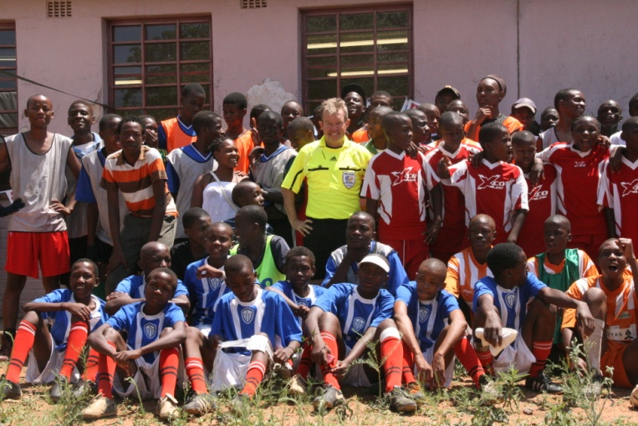
WHAT DO WE DO?
- Sport
Lesedi la Batho’s overall objective is to play a significant role in equipping the youth as drivers of social and economic change. The aim of our activities is to enhance the quality of life of vulnerable teenage boys and girls using sport as a tool to empower them with life skills which will not only develop their personality and character, but will also present life-changing opportunities.

Activities in our sport programme include:

- Professional soccer coaching and Talent Spotting by the SA Legends for competitive players enrolled at the 7 High Schools in Mabopane( Lesedi Strikers U12-U19 Boy and Girls sports teams)
- Capacity building workshops for coaches and peer educators in the Youth Development Through Football Program (YDF) developed by the German International Corporation
- Inter- School and special event Tournaments
- Weekly YDF Fitness and Training sessions conducted by Lesedi la Batho coaches at each of the 7 High Schools in Mabopane

- Education

The Pro-Active Information Programme
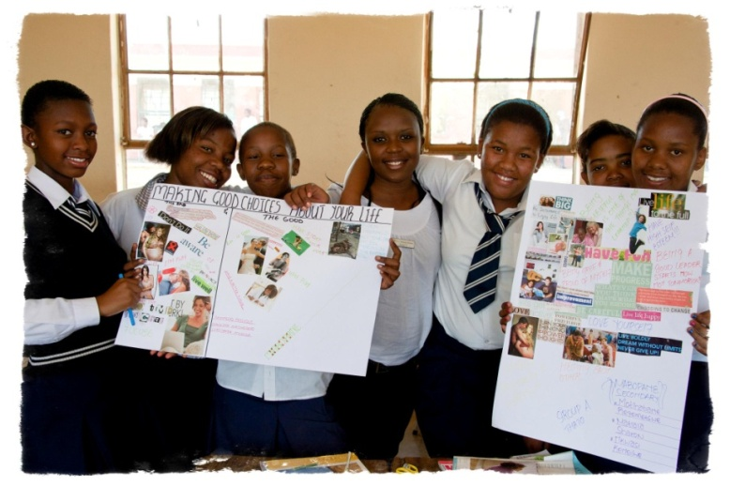
Information is the world’s key to a better life which can open the door to limitless opportunities that can change the destiny of one’s life. The concept of a local Pro-Active Information Program (PAIP) was inspired by the need to find an alternative and effective method to educate the youth to make better life choices. The program provides learners with the opportunity to access relevant and accurate information which empowers them with the knowledge to make positive choices about their emotional and physical wellbeing. Topics such as, “discover yourself”, “youth challenges past and present” and “teenage pregnancy – action and consequences” are covered in the manual. Through the interactive discussion part of the program, learners are encouraged to take up leadership responsibilities and occupy their minds with positive and productive thinking. Initially, Auxiliary Social Worker students were trained to present the 12-week information sessions, which also covered topics such as building self-esteem, reproductive health and knowing your rights. This program has now been adapted and incorporated into our USAID Sponsored TB project.

- USAID TB Project
As an organisation we pride ourselves on being a needs led NGO, meaning we identify needs within the community and adapt ourselves to meet this need, rather than pushing our ideas of what is needed onto community members. It is with this in mind, that we started our TB program. Nearly 30% of the Mabopane community is infected by TB, a curable disease. Yet, through lack of awareness, poor education and the stigma attached to being infected, many die unnecessarily from a disease which we can successfully combat. These are statistics that we could not ignore, and so we started the TB project.

The aim of the project is to raise awareness as well as combat TB in the Mabopane area. We have SocialAuxiliary Workers (SAW) and sports coaches placed in each of the 7 high schools in Mabopane as well as 2 workers from each profession based at the community centre. Together, they screen the learners from the schools and the community members from the centre for TB, assist with clinic appointments, monitor and support treatment plans for each infected learner as well as provide emotional support and education. We have adapted the Pro-active Information Program (PAIP) and the Youth Development through Football (YDF) toolkit in order to educate the learners about TB as well as other social issues. The SAW’s implement the innovative PAIP program in the classroom, whilst the sports coaches engage the children through football and teach them life skills using the YDF toolkit.Our aim is to ensure that learners, their families and the wider community are healthy, are educated on how to stay healthy and know how to help prevent further illnesses, specifically TB, in the future.
- Anti-abuse Program

In light of the growing instances of gender based violence in South Africa, Lesedi La Batho is uniting with others in the stand against sexual and physical crimes against woman and children. The statistics regarding rape and gender violence is horrifying, with the 2009 Medical Research study finding that 1 in 4 men in South Africa admitted to committing rape. The Medical Research Council (2011) also found that South Africa had a homicide rate 6 times the global average, with half the murdered women being killed by an intimate partner. It is no wonder with statistics like these that South Africa isoften dubbed the ‘rape capital of the world’.The brutal gang rape and mutilation of AneneBooysenamongst many others has shone scathing light on this monumental problem and has brought gender violence to the for front of the government agenda. However, recognizing there is a problem and actively implementing a successful and effective program are two very different challenges.

With this in mind, we have partnered with Arno and Ian Pienaar, two brothers who are Special Forces trained combat soldiers with a unique knowledge in both attack and defence skills. Together we are forming an anti-gender violence program which aims to:

- Inspire the community to stand up and not protect or condone sexual / physical violence against women and children
- Empower women by equipping them with the physical techniques to survive an attack
- Educate young boys and men on how to demonstrate their strength by means of protecting those more vulnerable rather than abusing them
- Teach culturally specific de-escalation techniques in order to prevent violent incidents
- Equip women and older children with the knowledge of how to physically prevent being raped if attacked
- Change the mindset of young boys so that they too do not become violent towards their partners of children in the future
There are 2 components to this course. Firstly, the Attack-Defence training which is primarily aimed at teaching women and older children the physical techniques required to fight off attackers. This includes teaching the physical positions which could prevent rape, as well as teaching de-escalation techniques in a culturally specific way to help avoid conflict which could lead to violence. The second component involves working with young teenage boys on a merit system, where they complete different modules which include Attack-Defence techniques as well as training on how to use their strength to protect and not harm women and children. They will work their way up the modules until they have reached the level where they can become trainers themselves. This will make the program sustainable as the skills will be passed on between community members.

- Sizani Skills Training and Social Enterprise Development
More than 55 community members from the Mabopane area are registered in the Sizani Program and are regularly attending the different training sessions at the Lesedi la Batho Centre in Mabopane. Although the group is primarily aimed at unemployed young mothers, we do have a handful or unemployed men in attendance who also want to improve their future prospects. All skills training services are provided free of charge to any interested community member.

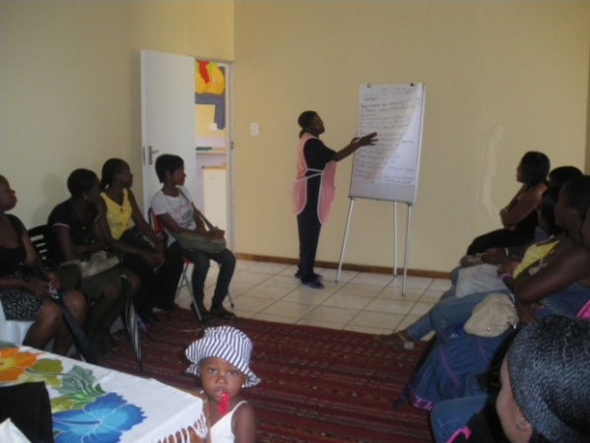
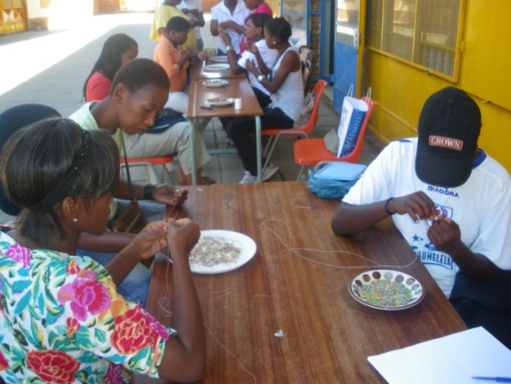
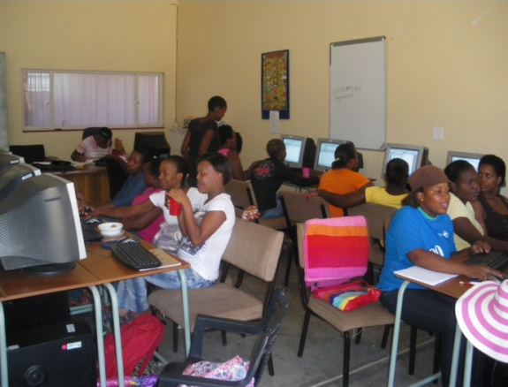
- Sizani Skills Training Programme
The main objective of the Sizani Skills Training Program is to improve the quality of life of both vulnerable young women and their children. The skills training encourages the participants to become empowered, financially independent, and self-sufficient members of the community. The group is split between the different workshops and then rotates after 2-3 months in each. After each workshop, we have a graduation ceremony to mark and celebrate the completion of the workshop and each group members gets a certificate of attendance before moving onto the next.
Activities in our skills training program include:
Computer Training - The women receive basic and more advanced computer training. Internet is provided at the centre free of charge and the women are encouraged to join social networks to practice their newly acquired computer skills in a fun and interactive way. Our computer laboratory manager is also able to assist them in creating their CV’s in order to help with employment prospects and also to apply for Job’s online.
Beading and Sewing - The art of sewing and beading is being taught to the women. In this workshop, they create beautiful beaded gift bags, jewellery and other such items which they can keep or give as a gift to others. They can also sell the items which they have made on and get 90% of the profit, giving further incentive to practice and improve on their craft skills.
Baby Care and Child Health Training - Basic baby health and hygiene forms part of this curriculum and aims to reduce the high infant mortality rate of babies in the area. They cover topics such as feeding, hygiene and providing the right nutrition to you baby. This course is very popular, especially with the young mothers which make up the majority of the Sizani group members.
Baking and Catering - This is a project which aims to teach participants in our projects cooking, baking, preserving, catering and business management skills. It also covers basic food hygiene which is instrumental is preventing illness in the area. Each trainee is allowed to take up to R30 of produce with them after each training session and the items made are sold in the bakery.

- Sizani Social Enterprise Development
Through our Social Enterprise Development initiative, we strive to be a catalyst for social entrepreneurship. Each of the training facilities has a business component which enables us to provide community members with a business opportunity to stimulate economic activity and growth in the community. We assist the entrepreneurs to grow their business so that it can create further employment and training opportunities for their community.

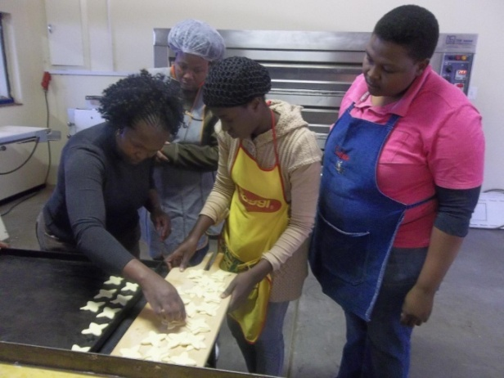
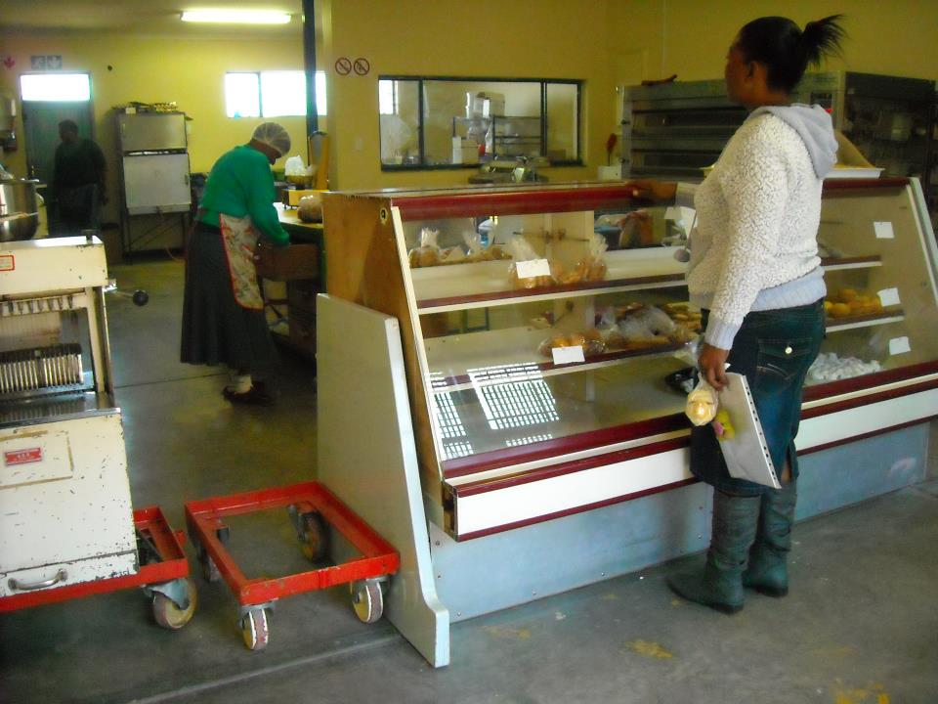
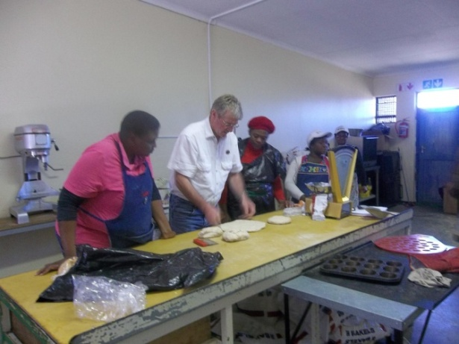

- Community Wellness

- The Sizani Support Programme
Through this programme support is given to teenage and unemployed mothers. Support includes: meeting their emotional and spiritual needs through counseling, discussion group sessions and education in the form of capacity building workshops.

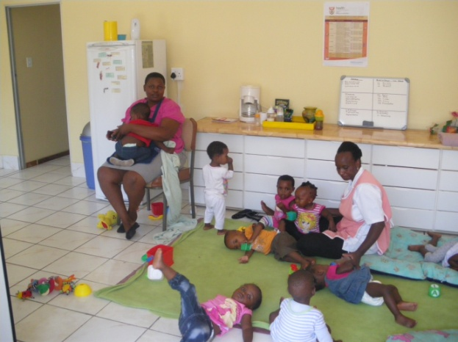
- Sizani Social Relief
Through Sizani Support we are able to provide Sizani mothers with practical support which include a free Baby Day Care service. Mothers are welcome to leave their babies in a safe environment whilst they receive skills training at the centre in order to become self-sufficient. Teenage mothers are also encouraged to bring their babies to the facility to return to school and complete their education. Working mothers pay a small fee for the service which helps with the sustainability of the project.
Food parcels, clothes and disposable nappies are also provided to Sizani mothers who live in extreme poverty and needs additional help.

- Food Parcels

As part of social relief for the community we provide food parcels for those who are unable to provide this for themselves and their families. At present, we provide around 100 food parcels a month, although this is dependent on donations. Our sports coachesalong with the school’steachers, identified the 10 families most in need of this support in each of the 7 High Schools in Mabopane, equating to 70 food parcels per month. We also provide food parcels to some of our sizani group members as well as to the bokomoso group. We also give some food parcels on a needs led basis and for emergencies.

- The Bokomoso Group

The Bokomoso (Meaning ‘future’) group is made up of commercial sex workers who are in need of support. We assist them with transport so that once a week they come to our centre to take part in our free training workshops, group discussions and a chance to socialise in a safe and trusting environment. We are also providing accredited training opportunities to the ladies, who aim to generate an alternative form of income for themselves and their families. They are also in receipt of social relief through the means of monthly food parcels and clothes donations.The women attend capacity building workshops and also decided to start a vegetable garden which is also attended to by a keen gardener in the community.This is very much a participant driven project where the women themselves set the agenda and can decide what they would like to do.

- Sustainable Livelihoods: Training and Employment Opportunities
Lesedi La Batho has become partners with the Department of Social Development under their ‘Sustainable Livelihoods’ project. The funding is enabling us to invest in training, community development, social relief and job creation. Over the course of the comingyear, we will be training 90 Community members in life skills as well as in the fields of: Basic and Advanced Computer Training, Basic Bookkeeping and Cashiers and Merchandising. As an organisation we will also then support our trainee’s in securing employment which will give them financial independence that will mean they can support their families.
As part of this partnership, we also run a Referral and Information Desk which acts as a gateway to our centre and services. Community members’ looking for employment and training opportunities have access to the daily newspapers, and can also have assistance from our Desk Manager in completing CV’s and applying for jobs online. The latest training courses, bursaries and job opportunities are also advertised. The service provides information about government departments, such as home affairs, which we can refer community members to when needed. The service makes referrals both internally to our different projects as well as externally. We also provide social relief, and make referrals to the Government’s food bank service. This service is means tested but will provide a family with 1 food parcel per month for a 3 month period.
Whilst the main Referral and Information desk is situated in the compute laboratory in the community centre, we also have 7 satellite desks based at the 7 high schools in Mabopane, which is open for a few hours 2 days per week. This aims to reach the more isolated members of the community who do not have access to the centre.

- Arts & Culture

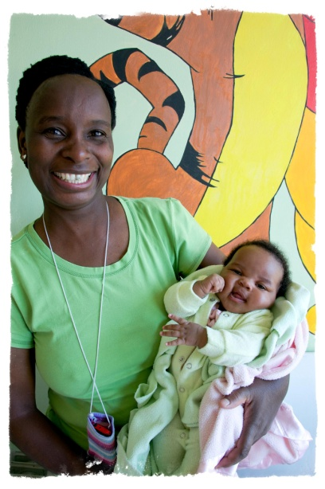
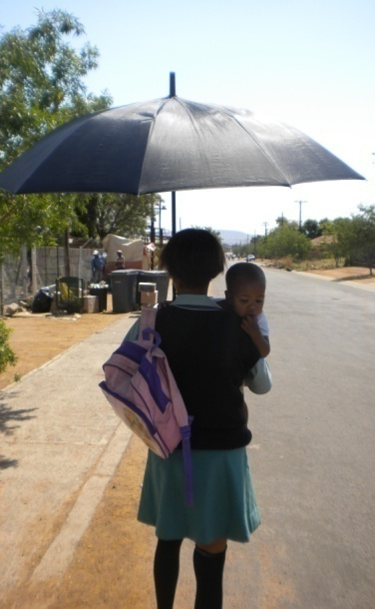
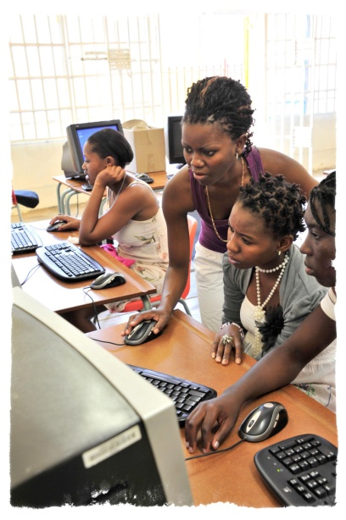
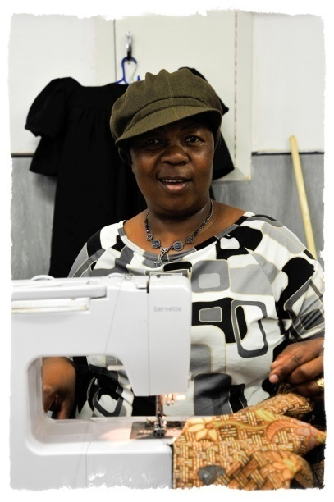
The Arts & Culture Programme focuses on the cultural aspect of community support and development. Art classes are conducted by a community artist at one of the schools in Mabopane for talented underprivileged artists.

